BPM Learning Points :-

1. view.getOption("BONAME").get("VarName");
2. me.context.binding.get("value");
3. view.context.binding.get("value").get("orderingCustomerDetails").get("creditValueDate");
4. view.getOption("varname");
5. var sql="select BANK_CODE as Name,BANK_NAME as value from sibawdb.TBL_RTGS_RCVR_BANK_DETAILS where BANK_CODE<>'OMBSHR'";

tw.local.deptDetails=[];

tw.local.deptDetails = tw.system.createFromSql("NameValuePair", tw.env.DataSource, sql);

1. "{{tw.local.swift.processData.nextStep}}"---Custom HTML
2. page.ui.get("/soharTemplate1/branchid").setEnabled(true);---Can be accessed in events and scripts in CSHS
3. ${svsURL}.setData(${Signature3['+ me.ui.getIndex()+']}.getData());---To access repeating data in layout

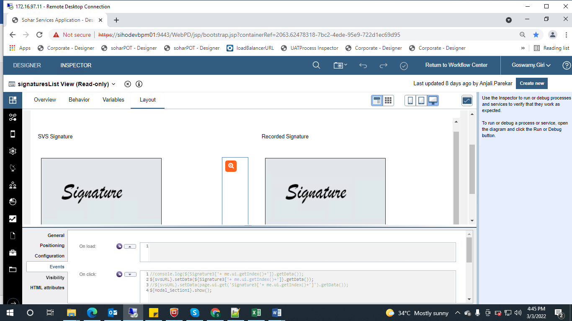

1. Access tabular data based on column

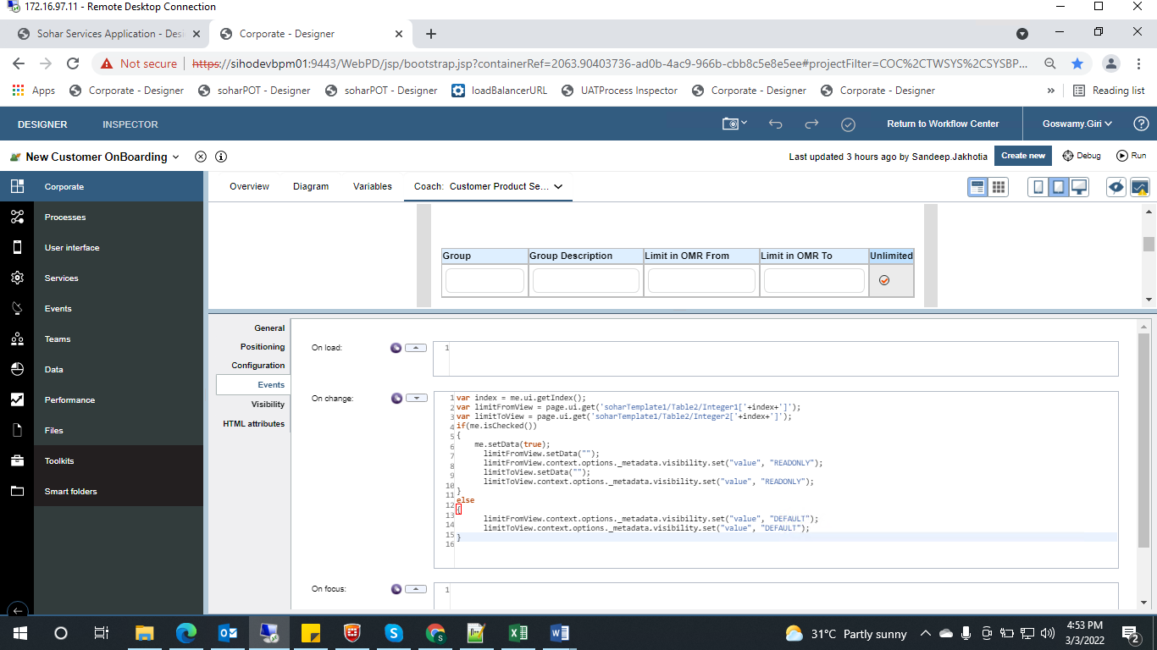

1. To retrieve document id and its name

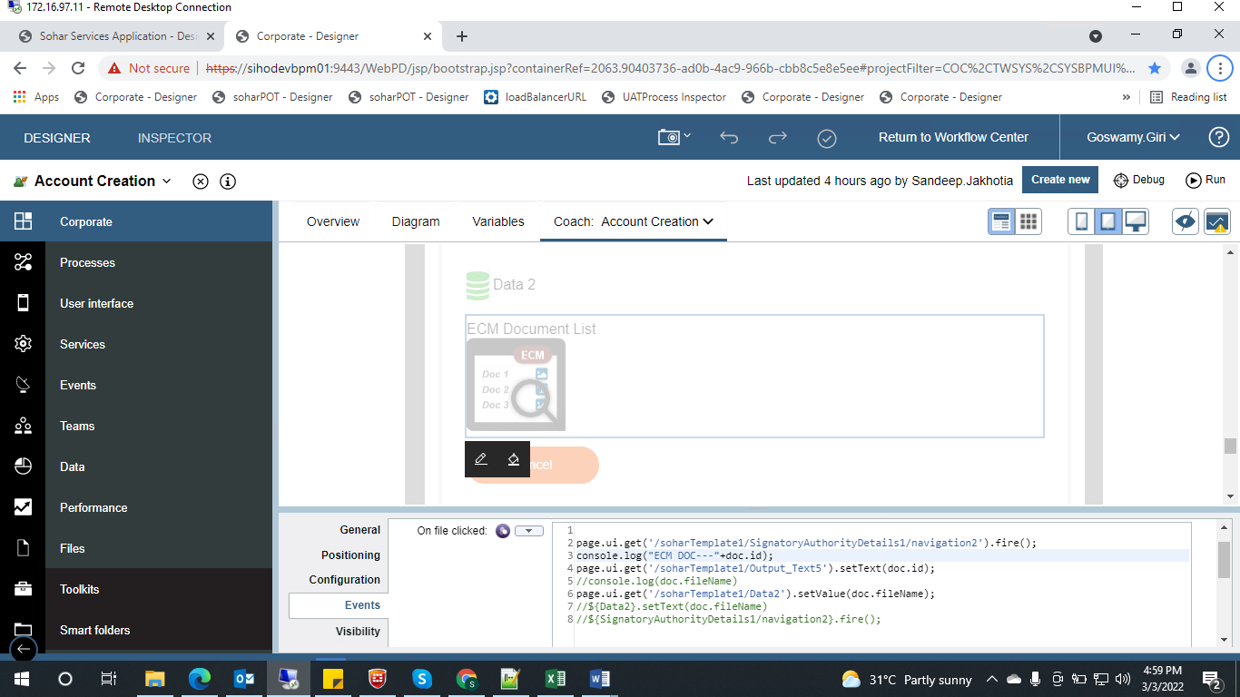

1. tw.system.coachValidation.addValidationError("tw.local.detailsOfProduct.schemeCode", "Please select Schemecode.");
2. (tw.system.coachValidation.validationErrors.length != 0)
3. _this.context.options.typeOfCustomer.get("value");
4. _this.ui.get("/soharTemplate1/CASA_Corporate_Accounts_List_CV1/Table1").getSelectedIndex();
5. _this.context.options.retailCustomerAccountDetails.get("value").get(i).set("viewUpdatedDetailsButtonVisibility", "READONLY");
6. 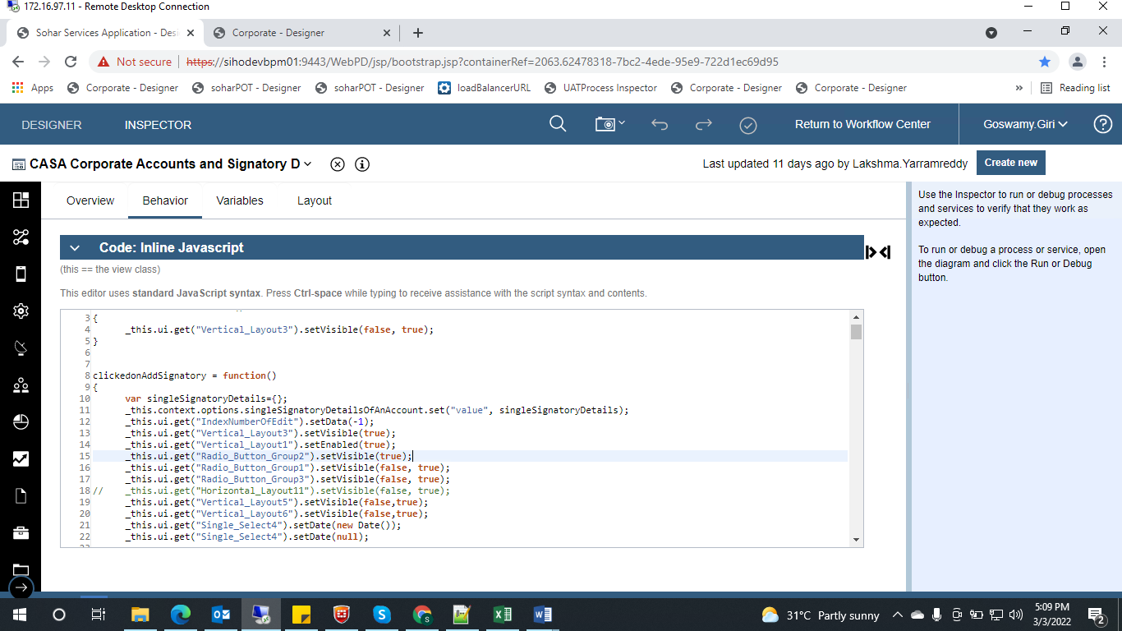
7. Add address panel or UI based on action

